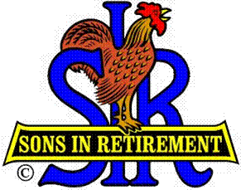
Las Trampas Branch 116
Luncheon Meeting Agenda
January 21, 2019, 11:30 AM
Martin Luther King Day

09:30 BEC Meeting
10:30 Social Hour
Greeters – Terry Grummitt and Hank Haugse
Raffle – Ben Bryce, Bob Huck
New Member Orientation – Dave Williams
11:25 Five Minute Call
11:30 Call to order; Opening Remarks – Big SIR
Pledge of Allegiance – Jim Nachtweih
Chaplain – Doug Aalders
Sunshine Report – Matt Arena
11:37 Story Teller – Fred Schafer
11:41 Introduce Speaker - Little SIR – Michael Barrington
Guests – Recruitment - Don Schroeder
New Member Induction – Member Relations – Bob Huck
Recognize Greeters – Jerry -
Awards – 20 year membership – Pete Kallas
11:45 Salad Served
RAMP Department Heads
Don Schroeder Bring A Guest
Activity Coordinator Announcement
Activity Committee Reports
11:54 Golf Committee Awards and Announcements – Bernie Wroblewski
12:00 Lunch
12:35 Finish Activity Reports
12:40 Intro and Speaker – Speaker Committee
Speaker Thank You
13:22 Drawing – Raffle Committee
Birthday Drawing – Michael Barrington
13:25 Sing Happy Birthday
Sing God Bless America
13:28 Closing Remarks - Reminder to bring guests; New Activities & Survey
13:30 Adjourn; Next Meeting, February 18, 2019

